DCS Experimental Information Collection Form
Laser Shock Experiment
Experimental Overview
Experiment Title

Experiment Dates

Lead Experimenter
(Name / Institution / Phone / E-mail)

Other Experimenters: Please limit onsite experimenters to two or less. | Email Address:
Scientific Objective

Number of experiments required to achieve scientific objective

List of Material(s)

Experiment Parameters
Configuration:  Undulator and Multilayer Monochromator (MLM) | ☐ U17.2, 24 KeV, 1st harmonic with MLM (standard)  ☐ U27, 36 keV with MLM  ☐ U17.2, 24 KeV, 1st harmonic without MLM  Other: _________________________________
Detector distance from target: | Min: 97mm  Requested: ____ mm
X-ray spectral scan required? | ☐Yes ☐No
Beam size at target: | Beam will be focused on target  Horizontal: 80 µm  Vertical: < 50 µm
Target Design:  Users should calculate x-ray attenuation from the sample and window and optimize thicknesses accordingly. DCS can help with this, if needed. | Range of Sample Thicknesses: ________ µm  Ablator Thickness: ________ µm  ☐Al-coated Kapton or ☐ Other:______________  Interferometry Window  ☐ LiF ☐None ☐ Other:______________  Thickness: ________ mm
Velocimetry:  Dual Line VISAR (Single Axis) and  Dual Point VISAR | Standard Line VISAR VPFs:  2,068 & 1,160 m/s/fringe  Standard Point VISAR VPFs:  1,554 & 748 m/s/fringe
Detail of issues from last DCS visit:
Lab Access and Shipping Requirements
If you request access to DCS laboratories and/or the machine shop, please specify your needs:

Review shipping requirements. If shipping materials in advance of your arrival date, provide shipment tracking numbers to dcs.admin@wsu.edu

Publication Requirements
The Acknowledgment Statement must be included in manuscripts for the work conducted at the Dynamic Compression Sector and published in journals, books, conference proceedings, or other printed scientific and technical media. Notification of accepted manuscripts require notification to DCS and APS. Send the copyright-free version of accepted manuscripts to dcs.admin@wsu.edu and enter your accepted manuscript into the APS Publications Database.

- Provide detail of in-press or published manuscripts that include any previous work performed at DCS.
- It is the expectation that users submitting non-proprietary proposals will publish, based on any experimental work at DCS, to the open literature. What date do you anticipate an accepted manuscript and/or publication based on the results of your upcoming scheduled experimental time at DCS?

Configuration Diagram
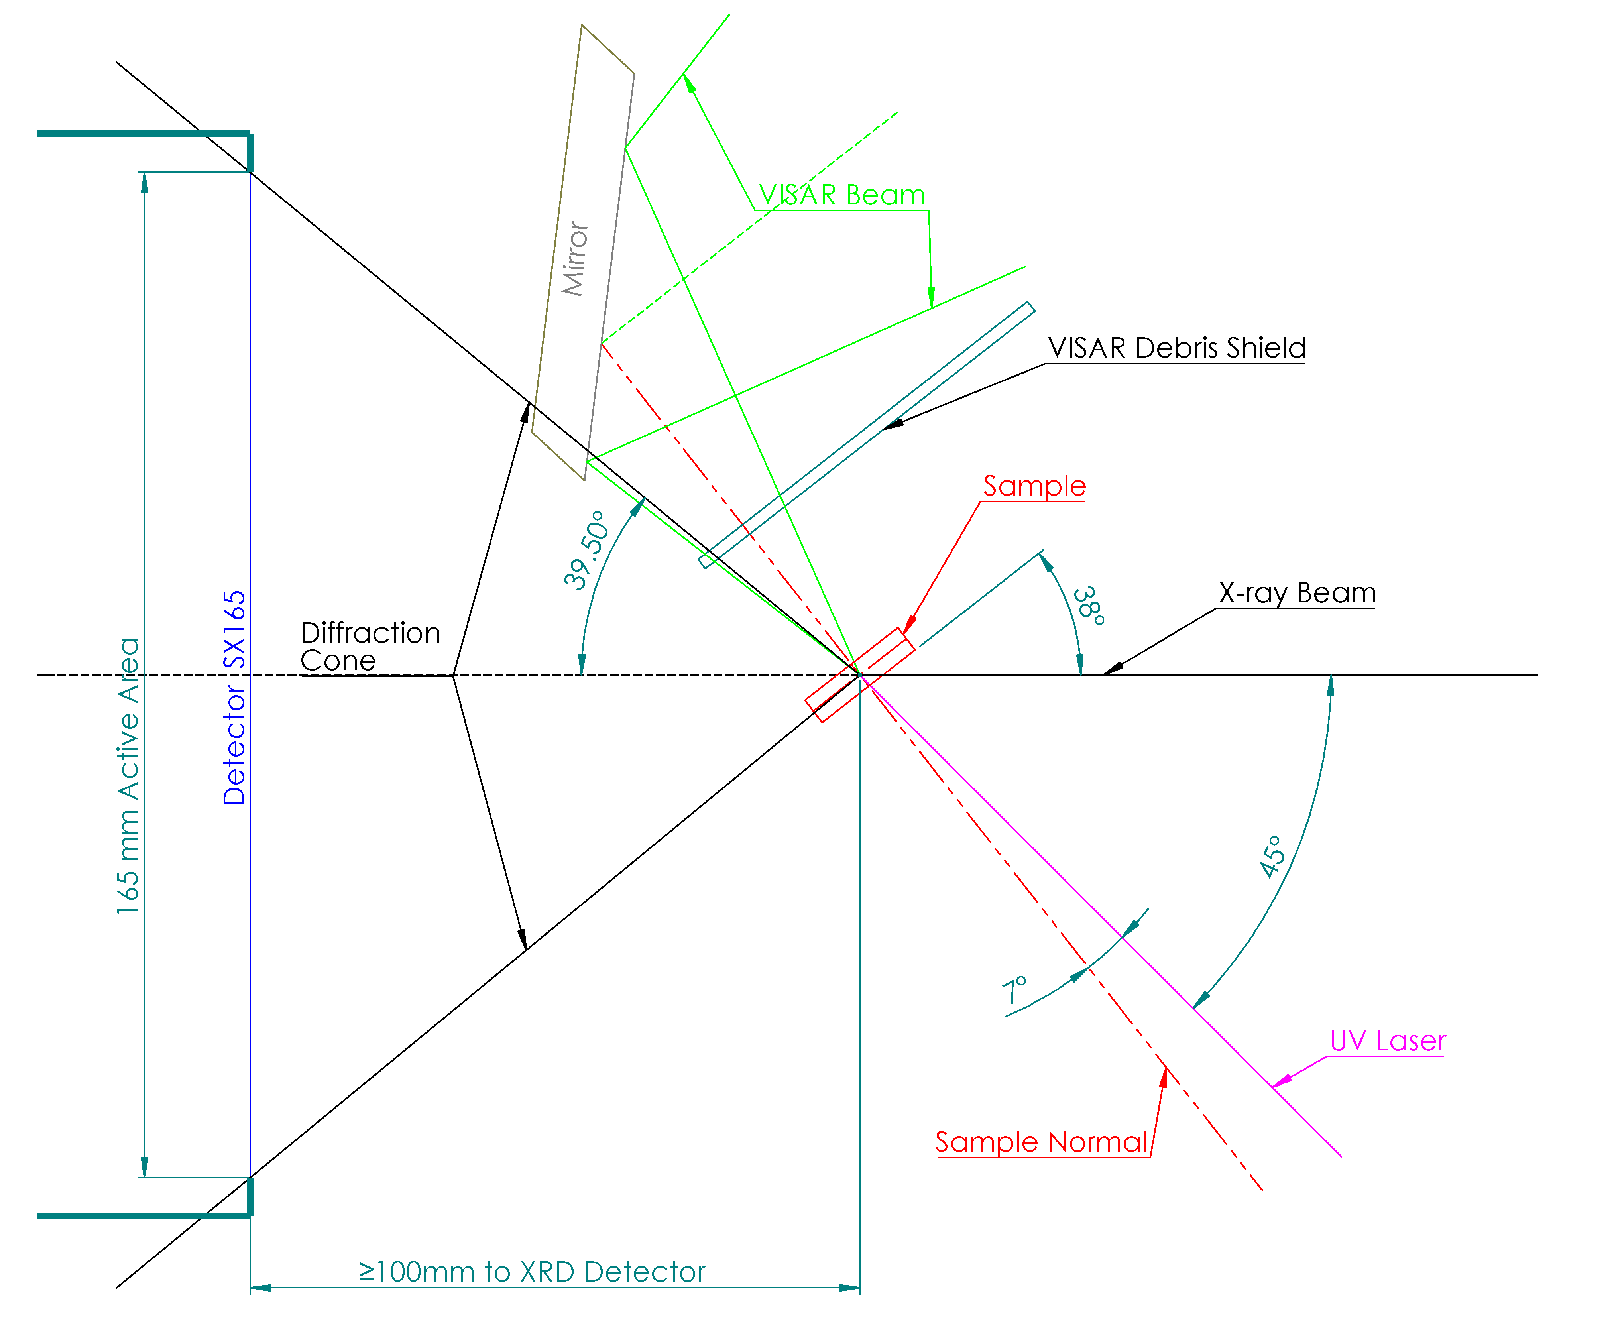
Additional Requests/Information
The DCS Team welcomes any additional experimental details, requests and information (attached diagrams, descriptions) that will assist in the preparation for your experimental time.

